STREAMLINING IT PROCUREMENT:
AUTOMATING STANDARD LAPTOP ORDERS WITH FLOW DESIGNER
1. INTRODUCTION
1.1 Project Overview
This project automates the procurement and configuration of standard laptops in ServiceNow using Flow Designer. The workflow creates a catalog task after approval and assigns it to the Hardware team for configuration.
1.2 Purpose
The purpose is to reduce manual effort, avoid delays and ensure that standard laptops are configured promptly after approval, improving the overall procurement process.
2. IDEATION PHASE
2.1 Problem Statement
Standard laptop requests require configuration, but manual handling can cause oversight and delays. This increases user waiting time and creates unnecessary workload for the IT procurement team.
2.2 Empathy Map Canvas
Users need a simple and timely laptop-request process. The IT procurement team needs automatic task creation and assignment so that configuration is not missed after approval.
2.3 Brainstorming
The proposed idea was to use ServiceNow Flow Designer to automatically create a catalog task, update its details and assign the task to the Hardware group once the request is approved.
3. REQUIREMENT ANALYSIS
3.1 Customer Journey map
The process begins when a user orders a Standard Laptop through the Service Catalog. The request is submitted for approval, and after approval the automated flow creates a catalog task and assigns it to Hardware for configuration.
3.2 Solution Requirement
The solution requires ServiceNow, Flow Designer, a Standard Laptop service catalog item, an approval process and a Hardware assignment group.

3.3 Data Flow Diagram
User request → Standard Laptop Service Catalog → Approval → Flow Designer trigger → Create Catalog Task → Hardware assignment → Laptop configuration.
3.4 Technology Stack
ServiceNow platform, Flow Designer, Service Catalog and ServiceNow workflow/task management.
4. PROJECT DESIGN
4.1 Problem Solution Fit
The automated workflow directly addresses delays and manual overhead by creating and assigning configuration tasks automatically after approval.
4.2 Proposed Solution
A Flow named “Standard Laptop Task” is created in Flow Designer. When the Service Catalog process triggers the flow, it creates a Catalog Task with the required description, assigns it to Hardware and processes only approved requests.
4.3 Solution Architecture
The architecture consists of the Service Catalog request, approval stage, Flow Designer automation and Catalog Task assigned to the Hardware team. The task status can then be monitored through the Requested Item record.
5. PROJECT PLANNING & SCHEDULING
5.1 Project Planning
The implementation is organized into three milestones: creating the automation flow, assigning the flow to the Standard Laptop service catalog item, and testing the complete Service Catalog ordering and approval process.
6. FUNCTIONAL AND PERFORMANCE TESTING
6.1 Performance Testing
The workflow is tested by placing a Standard Laptop order, approving the request and checking the Requested Item record. The generated Catalog Task is verified for its updated short description and Hardware assignment.
7. RESULTS
Output Screenshots

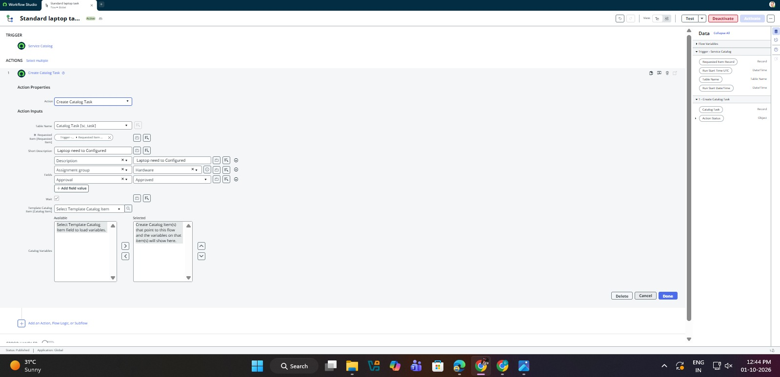
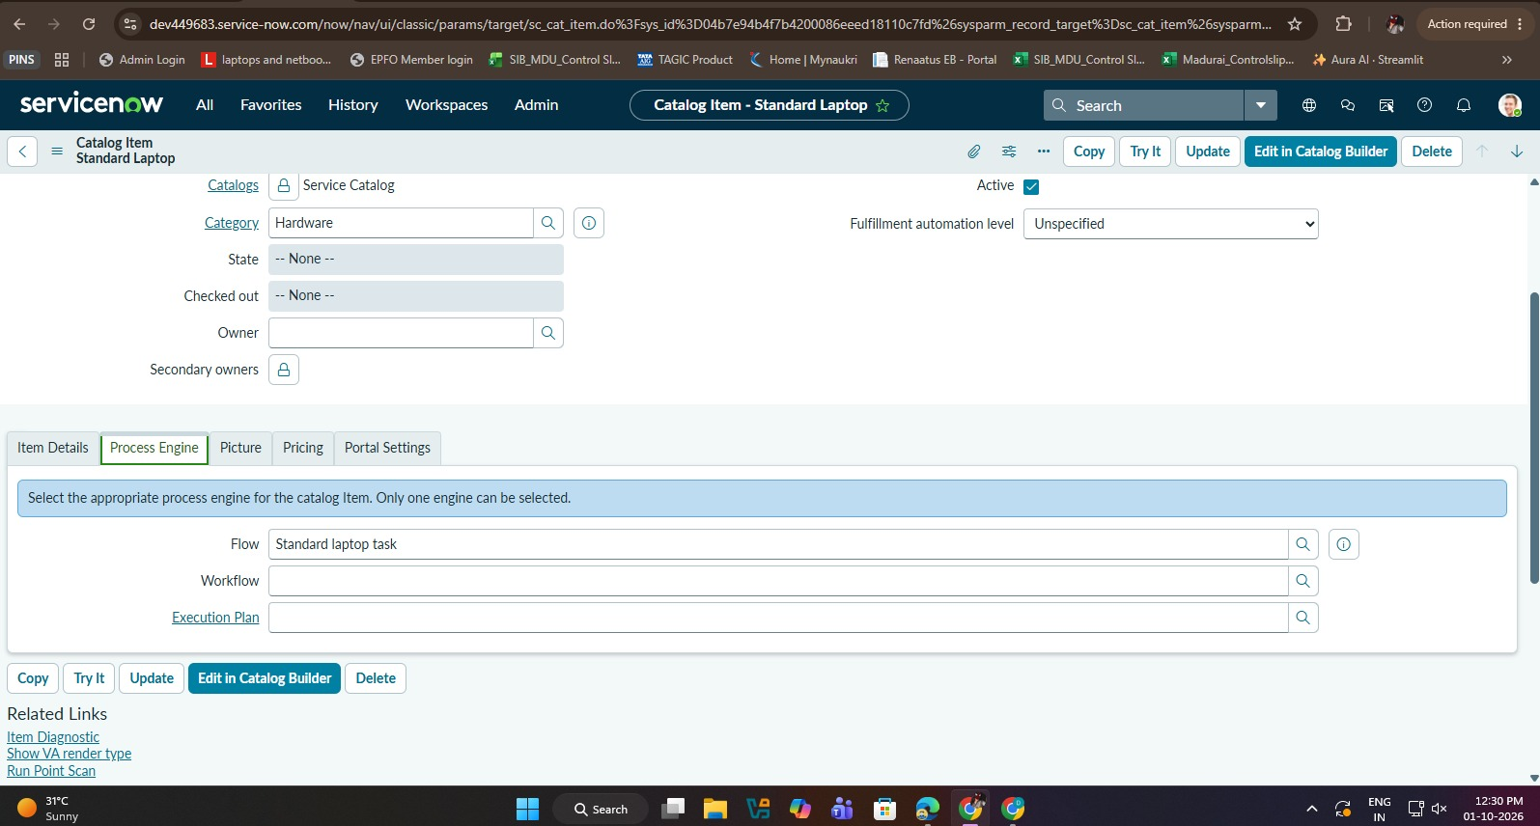
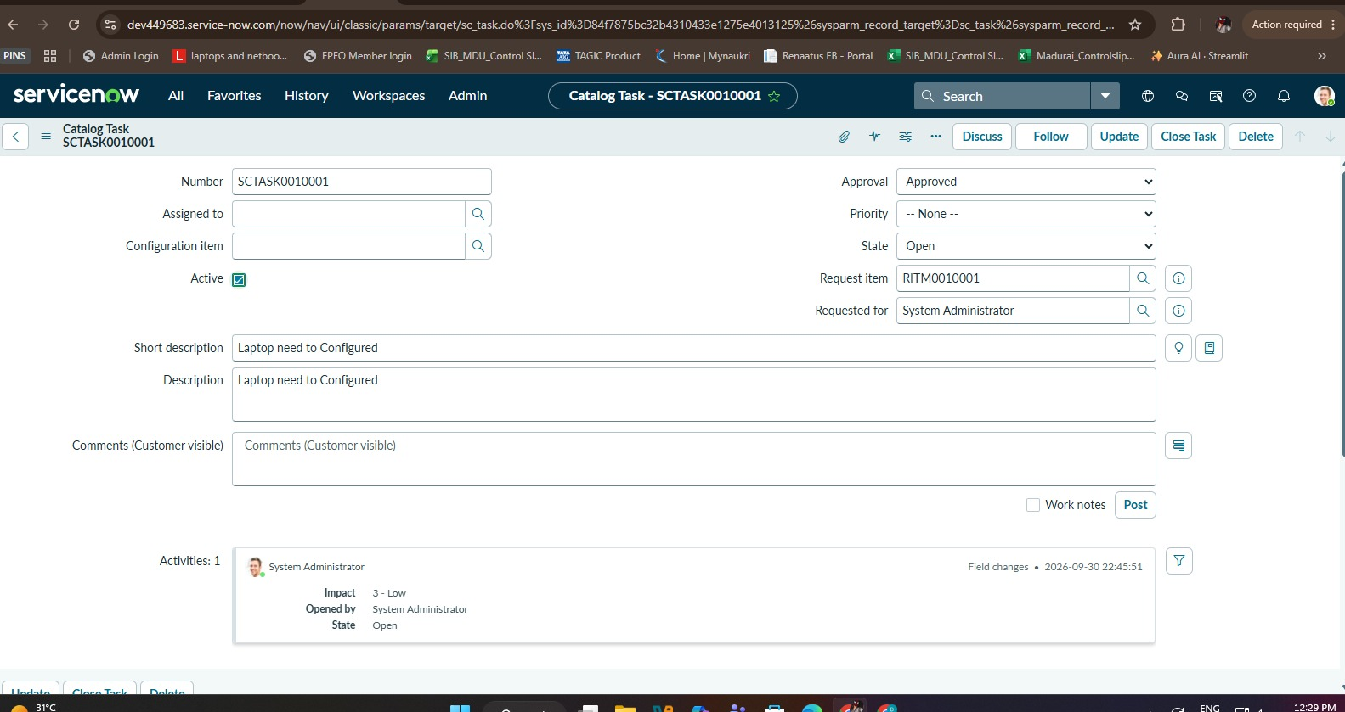

8. ADVANTAGES & DISADVANTAGES
8.1 Advantages
Reduces manual intervention; improves task allocation; minimizes delays and errors; supports timely laptop configuration; improves user experience and IT productivity.
8.2 Disadvantages
The workflow depends on correct ServiceNow configuration, approval completion and availability of the Hardware assignment group.
9. CONCLUSION
The project successfully streamlines standard laptop procurement using ServiceNow Flow Designer. By automatically creating and assigning configuration tasks after approval, it reduces manual overhead, minimizes user waiting time and improves IT resource utilization.
10. FUTURE SCOPE
The workflow can be further extended with additional automation, notifications, task tracking and integration with other IT procurement activities to provide a more complete automated procurement process.
11. APPENDIX
Source Code (if any)
No source code is provided in the project document; the implementation is configured using ServiceNow Flow Designer.
Dataset Link
Not applicable.
GitHub & Project Demo Link
GitHub Link : https://github.com/csksanthoshkmr/Naan_Mudhalvan
Project Demo Link: Naan_Mudhalvan - Google Drive

